Exp 14

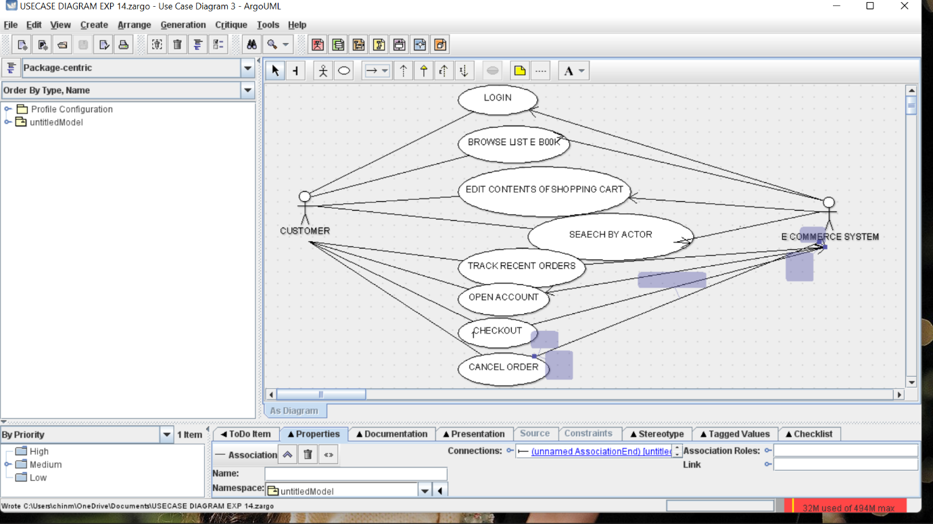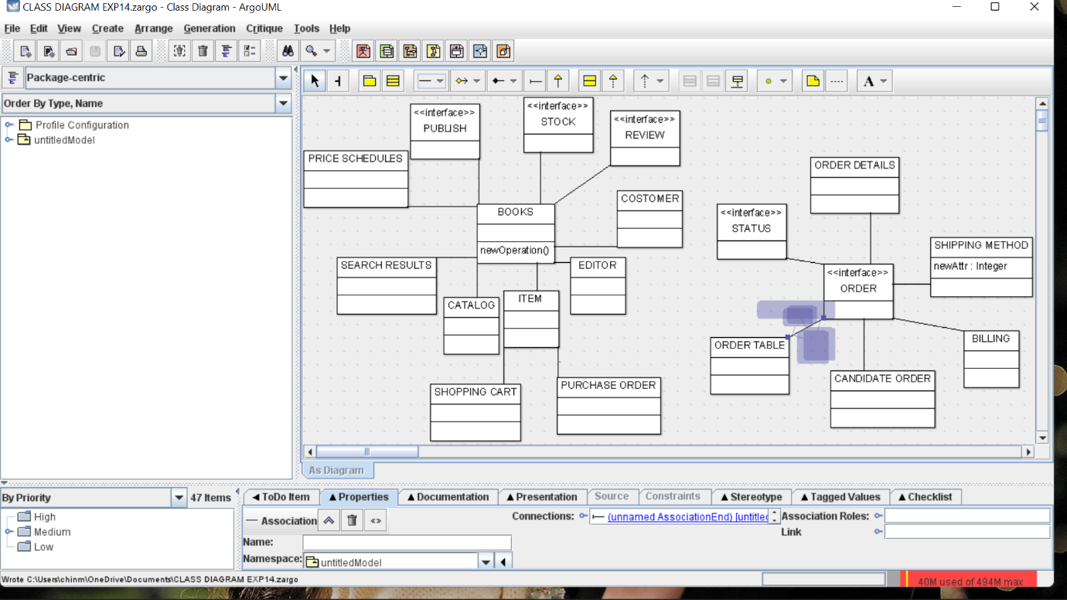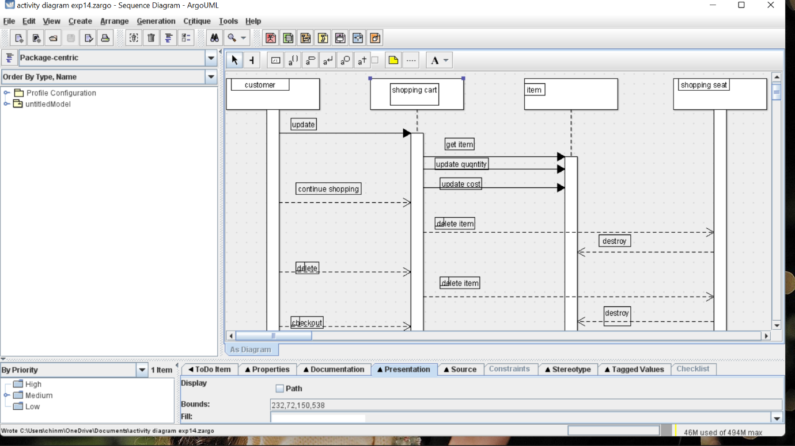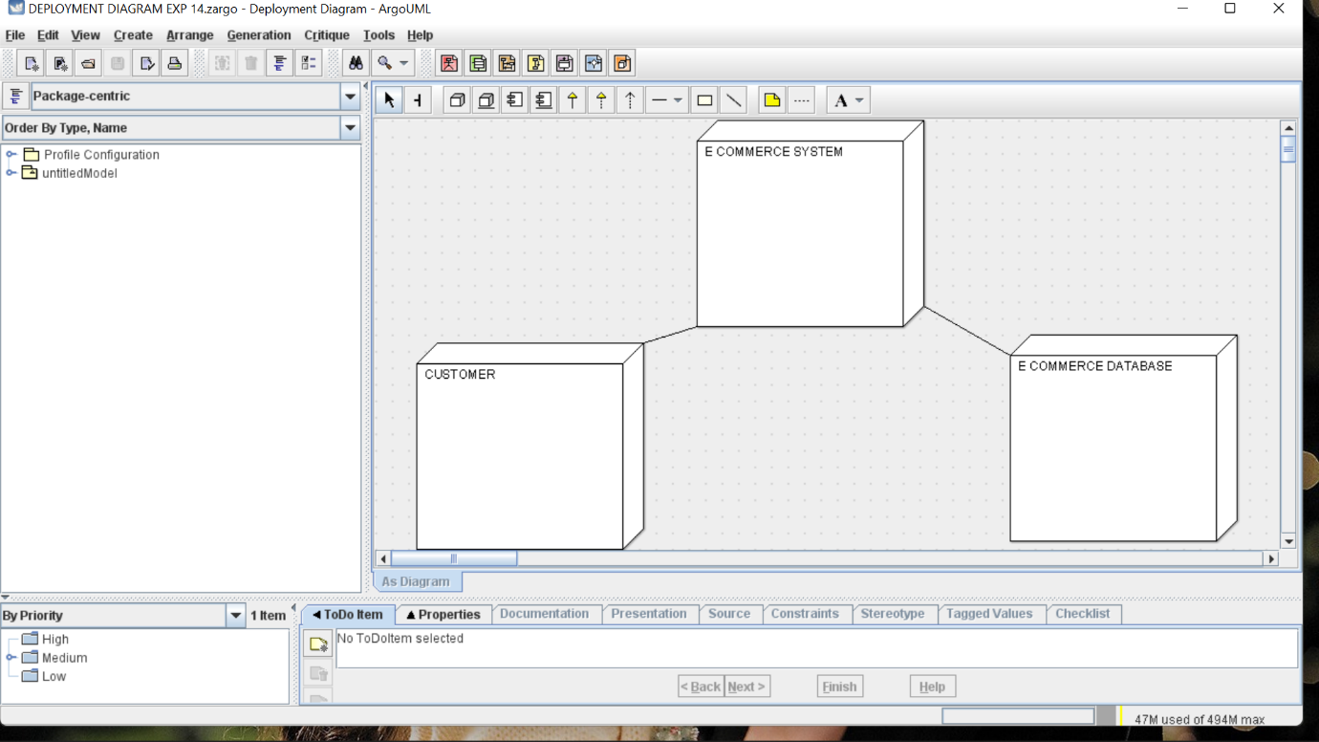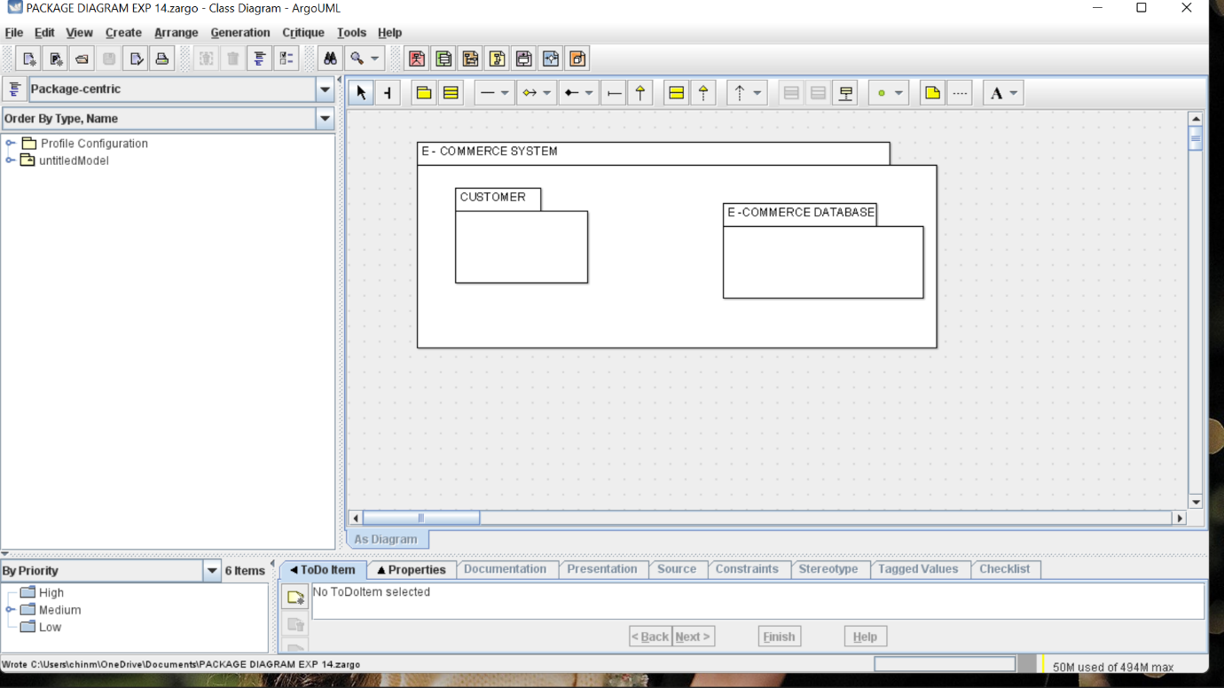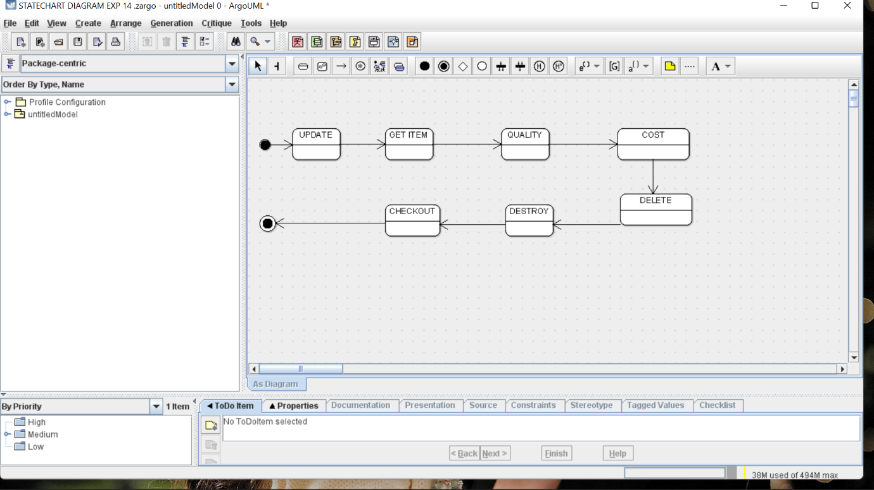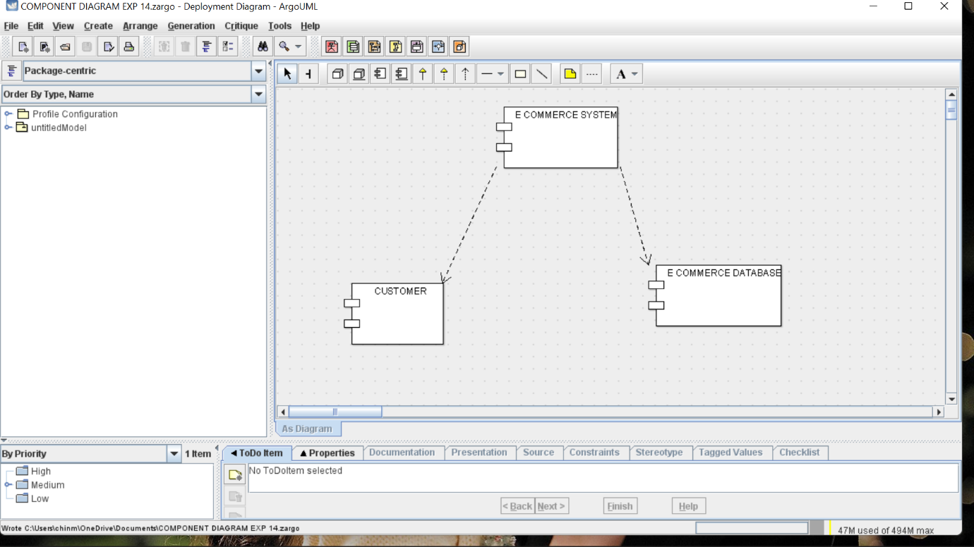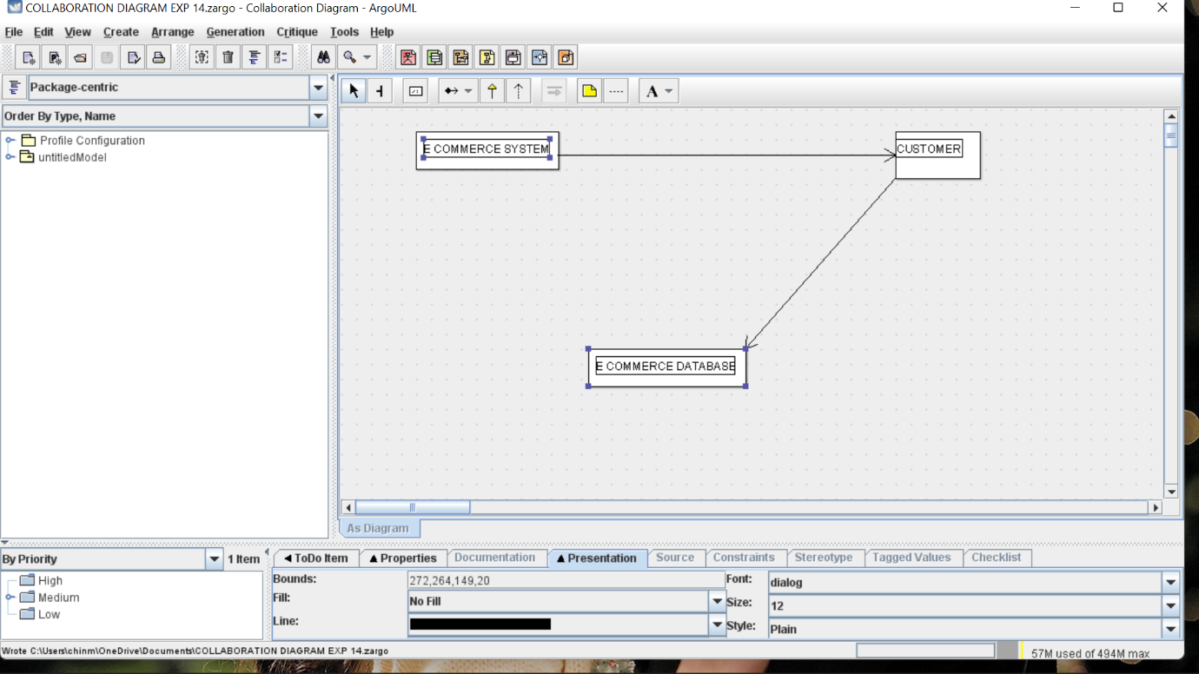

Skeleton code

import java.util.Vector;

public class BILLING {

public Vector myORDER;

}

import java.util.Vector;

public class BOOKS {

public Vector myPUBLISH;

public Vector mySTOCK;

public Vector myREVIEW;

public Vector myCOSTOMER;

public Vector myEDITOR;

public Vector myITEM;

public Vector myCATALOG;

public Vector mySEARCH RESULTS;

public Vector myPRICE SCHEDULES;

public void newOperation() {

}

}

import java.util.Vector;

public class CANDIDATE ORDER {

public Vector myORDER;

}

import java.util.Vector;

public class CATALOG {

public Vector myBOOKS;

}

import java.util.Vector;

public class COSTOMER {

public Vector myBOOKS;

}

import java.util.Vector;

public class EDITOR {

public Vector myBOOKS;

}

import java.util.Vector;

public class ITEM {

public Vector myBOOKS;

public Vector myPURCHASE ORDER;

public Vector mySHOPPING CART;

}

import java.util.Vector;

public class ORDER DETAILS {

public Vector myORDER;

}

import java.util.Vector;

public class ORDER TABLE {

public Vector myORDER;

}

import java.util.Vector;

public interface ORDER {

public Vector mySTATUS;

public Vector myORDER DETAILS;

public Vector mySHIPPING METHOD;

public Vector myBILLING;

public Vector myCANDIDATE ORDER;

public Vector myORDER TABLE;

}

import java.util.Vector;

public class PRICE SCHEDULES {

public Vector myBOOKS;

}

import java.util.Vector;

public interface PUBLISH {

public Vector myBOOKS;

}

import java.util.Vector;

public class PURCHASE ORDER {

public Vector myITEM;

}

import java.util.Vector;

public class PURCHASE ORDER {

public Vector myITEM;

}

import java.util.Vector;

public class SEARCH RESULTS {

public Vector myBOOKS;

}